**CHRIST (Deemed to be University)**

**Department of Computer Science**

**MSc – Artificial Intelligence and Machine Learning**

**Name:** Syed Mohammed Luqmaan (2448552)

**Course:** Java Lab

**Lab Experiment:** 1

**LAB 1:**

1. **Description :**

This program, named Lab1a, is designed to validate a credit card number using a simplified version of the Luhn algorithm. The purpose of this program is to ensure that the credit card number follows certain rules and calculations that help verify its validity.

This program ensures basic validation of credit card numbers using a systematic approach.

**Output:**

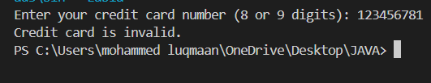

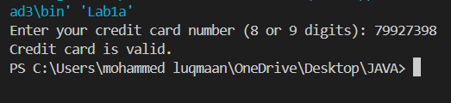

1. **Description:**

This program implements a game called "Alphabet War" where two sides (left and right) compete based on the strength of certain letters. Each side has specific letters assigned to it, with varying strengths, and the goal is to determine which side has a higher score based on the characters in the input word(s).

The game compares the strengths of the letters assigned to the left and right sides. It uses helper methods to calculate the score for each side based on the input letters, and determines the winner accordingly.

**Output:**

